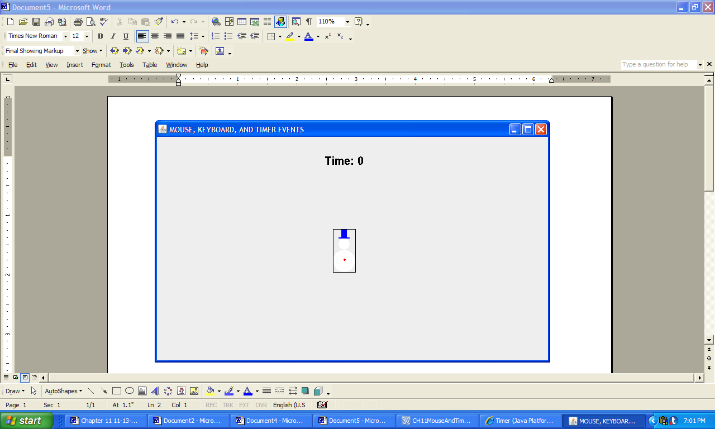 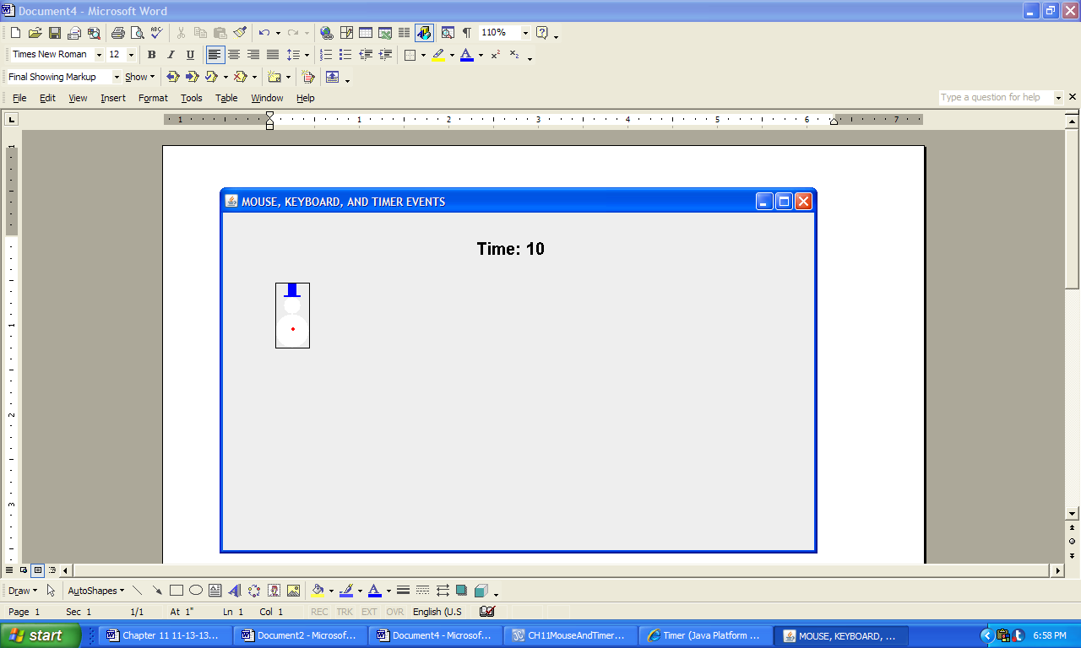

a) b)

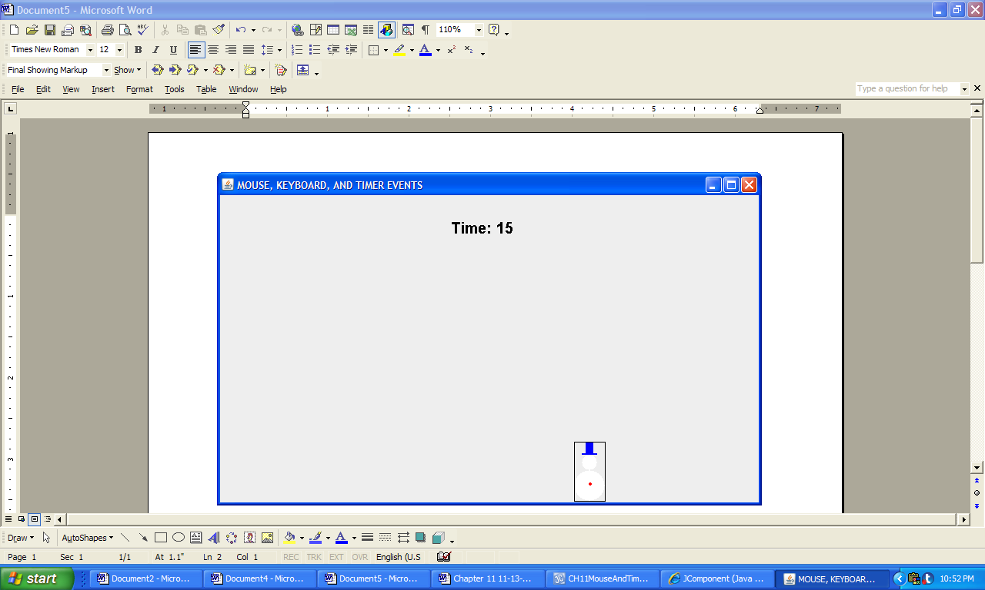 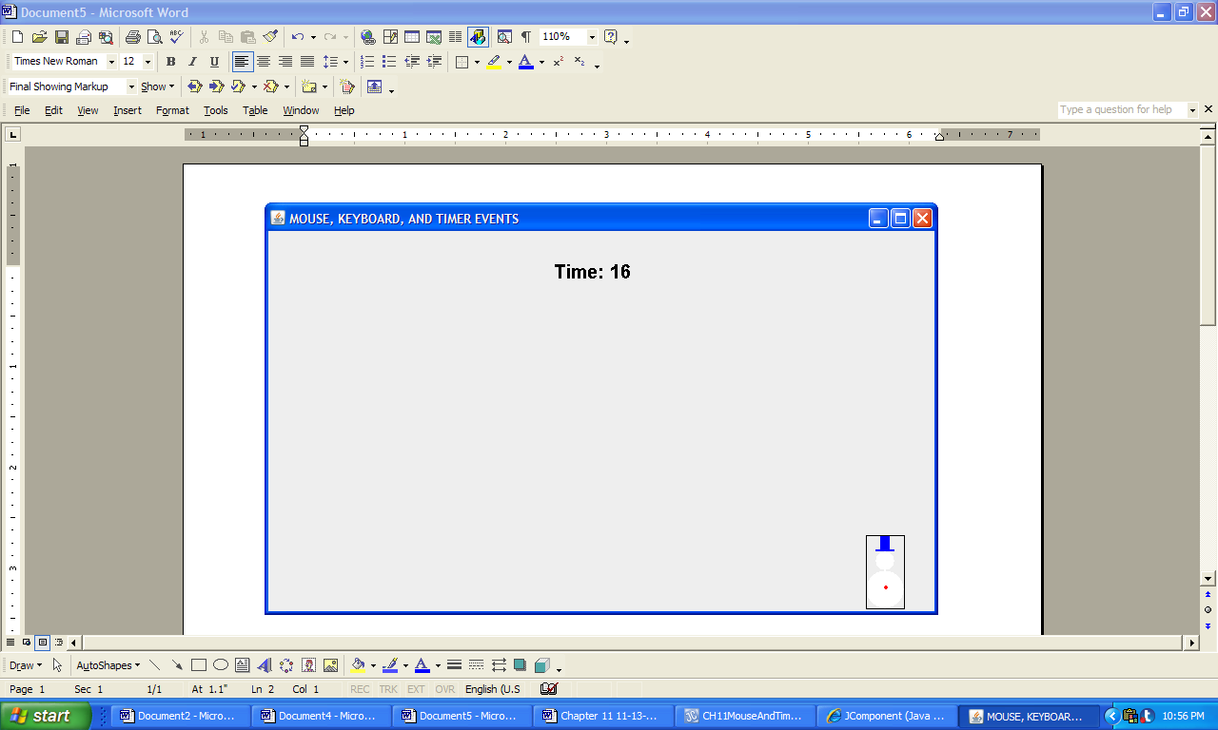

c) d)

*Console output*

Entered

Exited

**Figure 11.30 The window and console output produced by the application MouseKeyboardAndTimerEvents.**